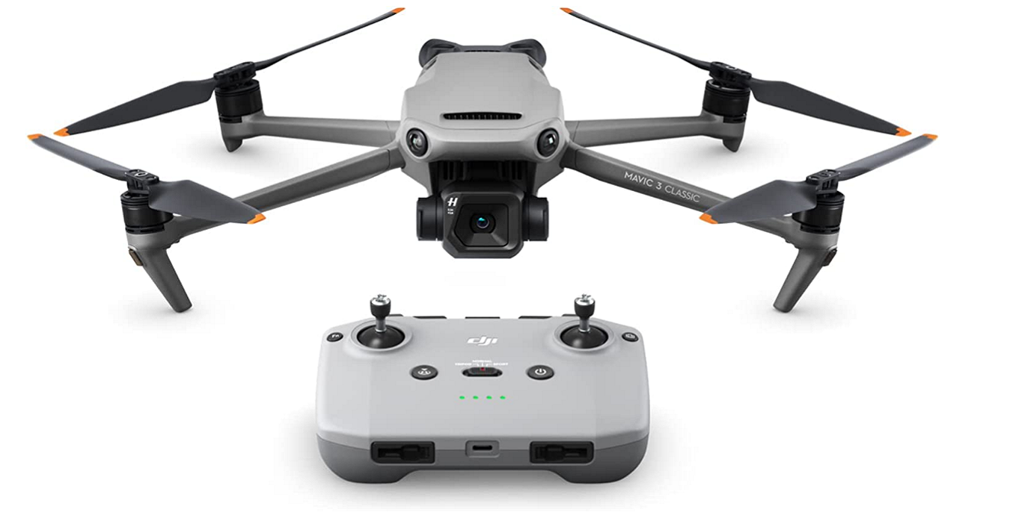

**DJI Mavic 3 Classic**

* **4/3 CMOS Hasselblad Camera - The legendary Swedish brand Hasselblad customized the L2D-20c aerial camera f or the Mavic 3 Series, embedding a professional-grade 4/3 CMOS into an incredibly compact space.**
* **5.1K HD Video - Professional-grade imaging performance for sharper details. It can also record 4K/60fps pictures through oversampling technology.**
* **46-Min Max Flight Time - Compatible with Mavic 3-**Series **batteries for up to 40 minutes of hovering and up to 46 minutes of flight time. Empowers creators to capture more content with less worry.**
* **Omnidirectional Obstacle Sensing - With APAS 5.0, Mavic 3 Classic can detect objects in all directions at all times during flight, and smoothly avoid obstacles, making flights exceptionally safe.**
* **15km HD Video Transmission - Mavic 3 Classic offers a 15km (9.3 miles) max transmission range. This extends shooting possibilities with stable signal and a crystal-clear 1080p/60fps feed.**
* **The Waypoint Flight function allows Mavic 3 Classic to automatically fly (and precisely repeat) flight routes along pre-selected aerial points.**

**Price $1,749.00**